Rahma Mahmoud
IOT

1- Use systemctl to view the status of all the system services.

Systemctl list-unit-files –type service

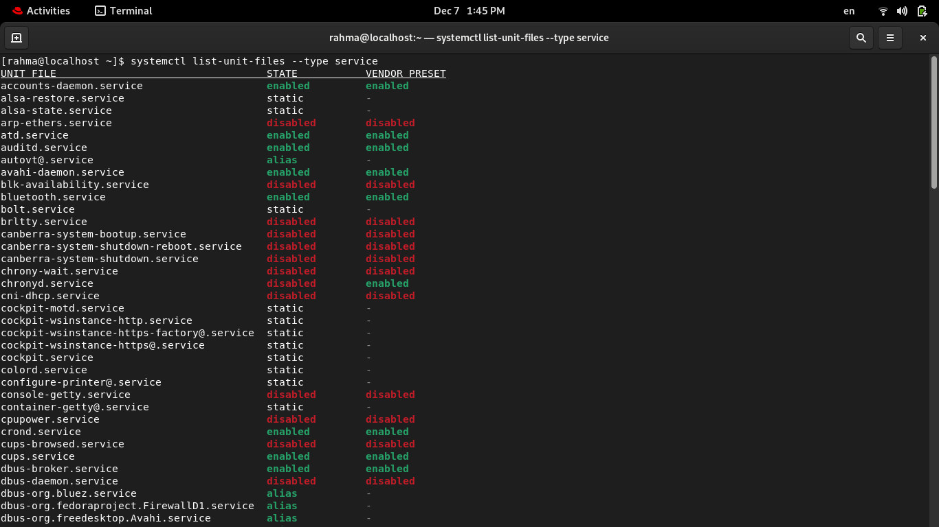
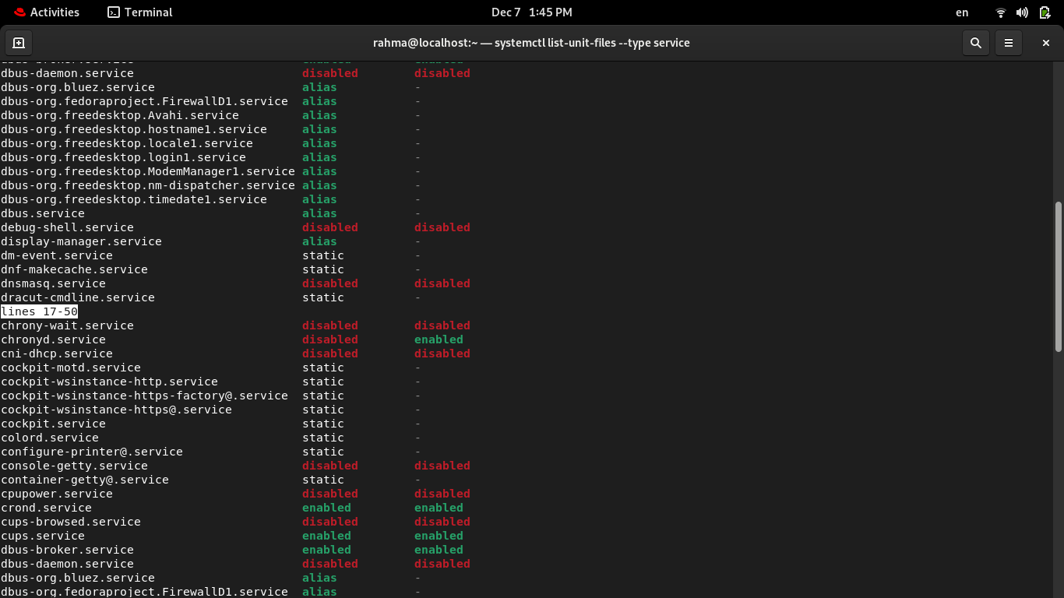

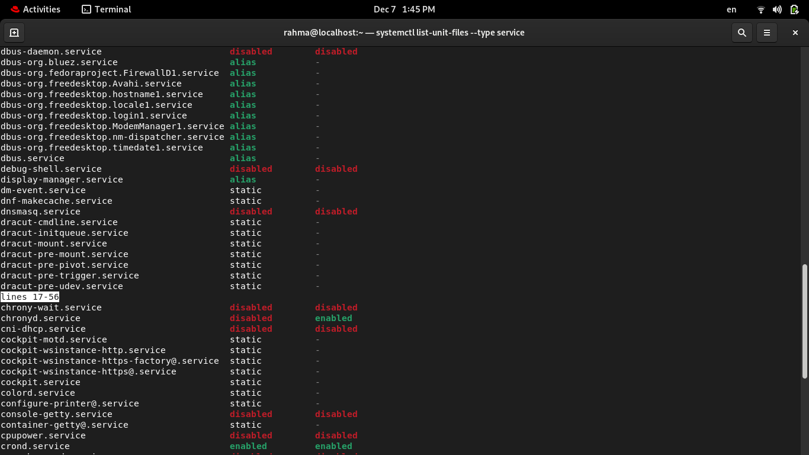

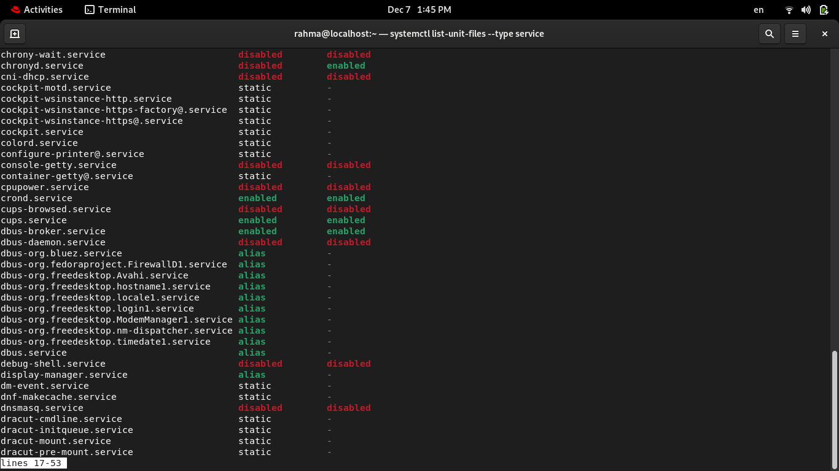
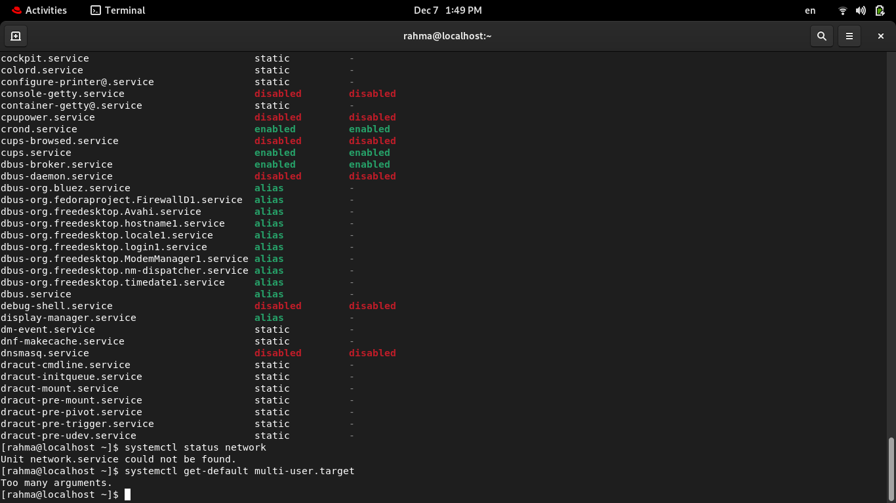
2-Change the default run level back to multi-user.target and reboot.
systemctl set-default multi-user.target
sudo reboot
systemctl set-default graphical.target
sudo reboot
3-Send mail to the root user.

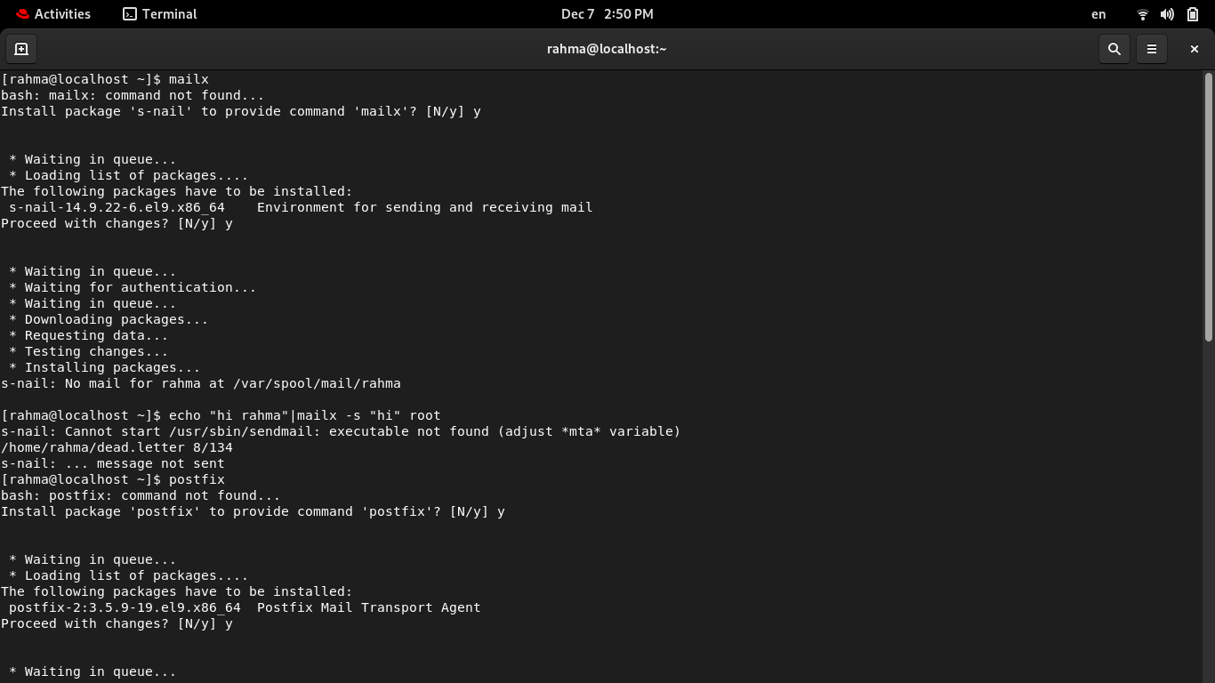
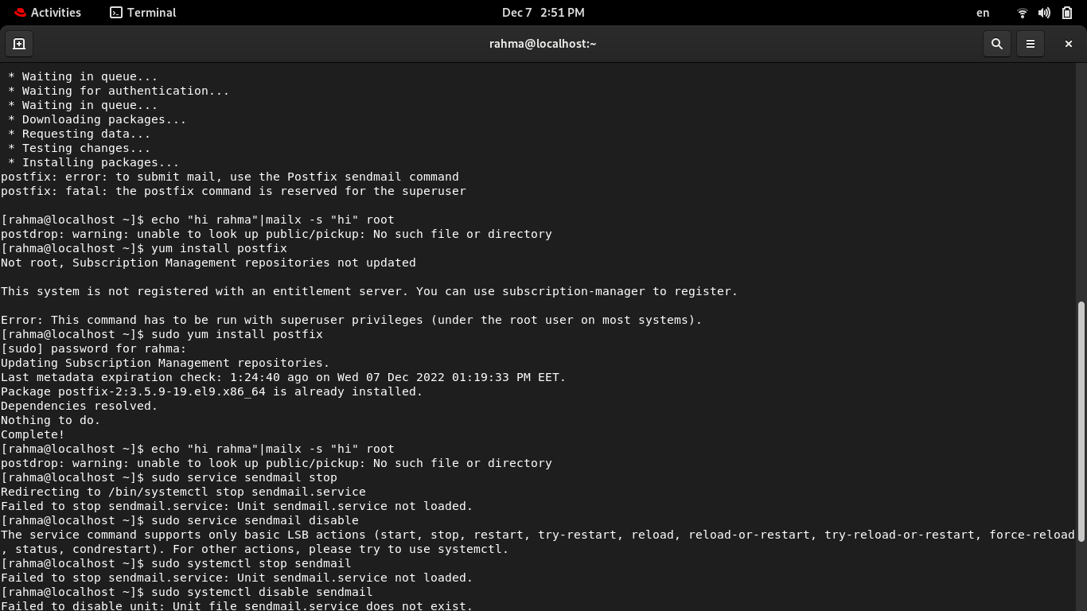
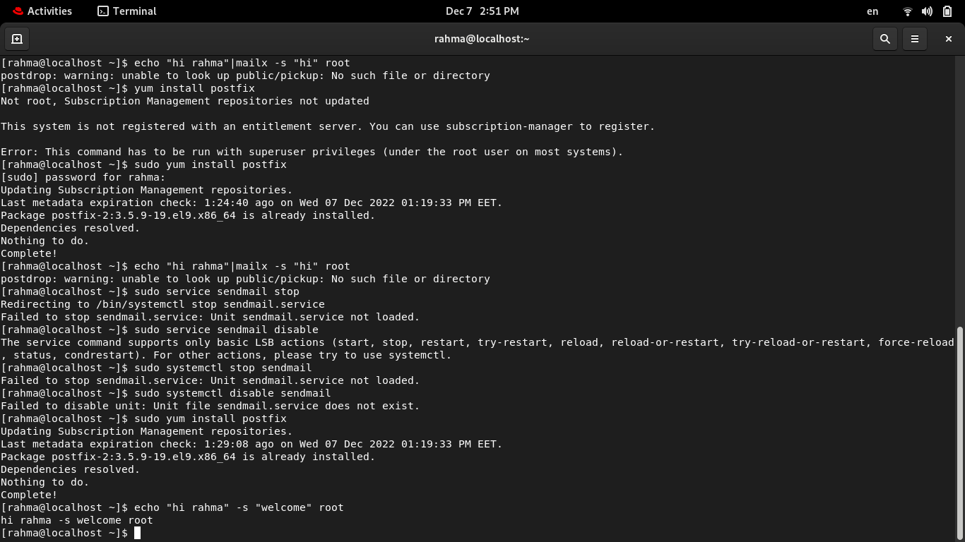
4-Verify that you have received this mail.

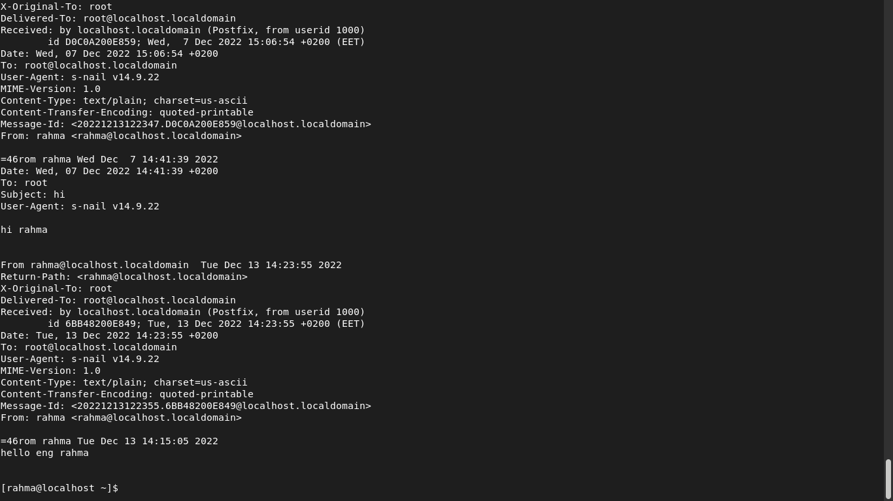

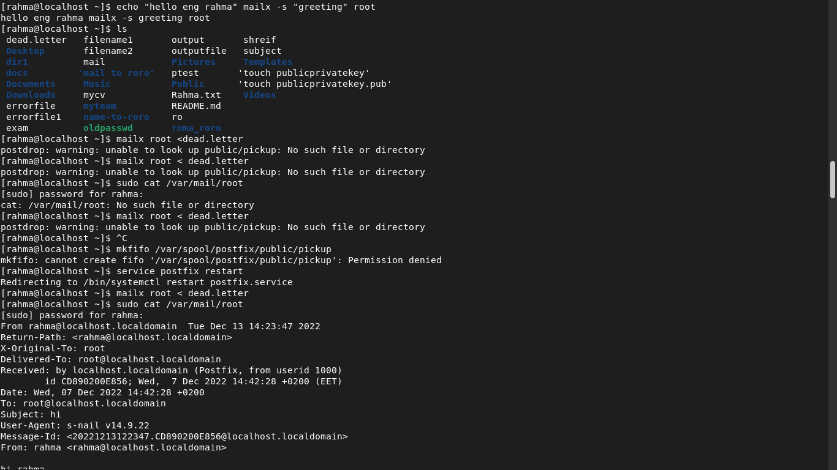
5. Use systemctl utility to stop postfix service
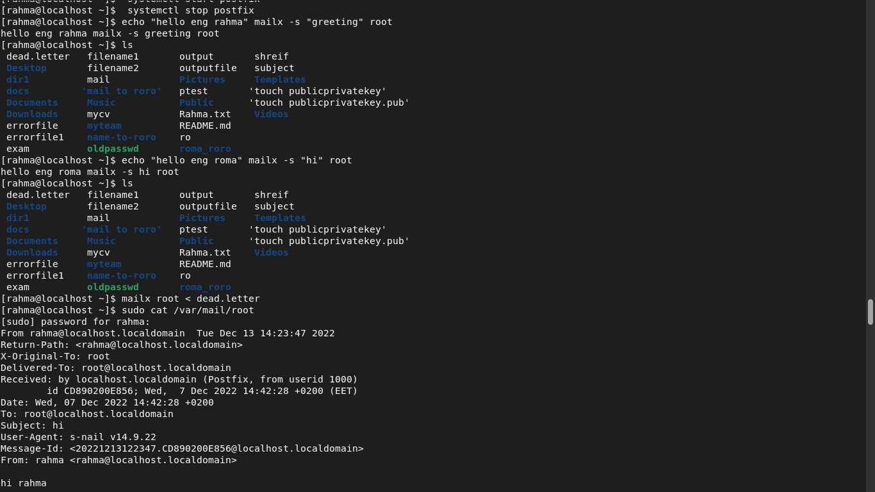
6.Send mail again to the root user.

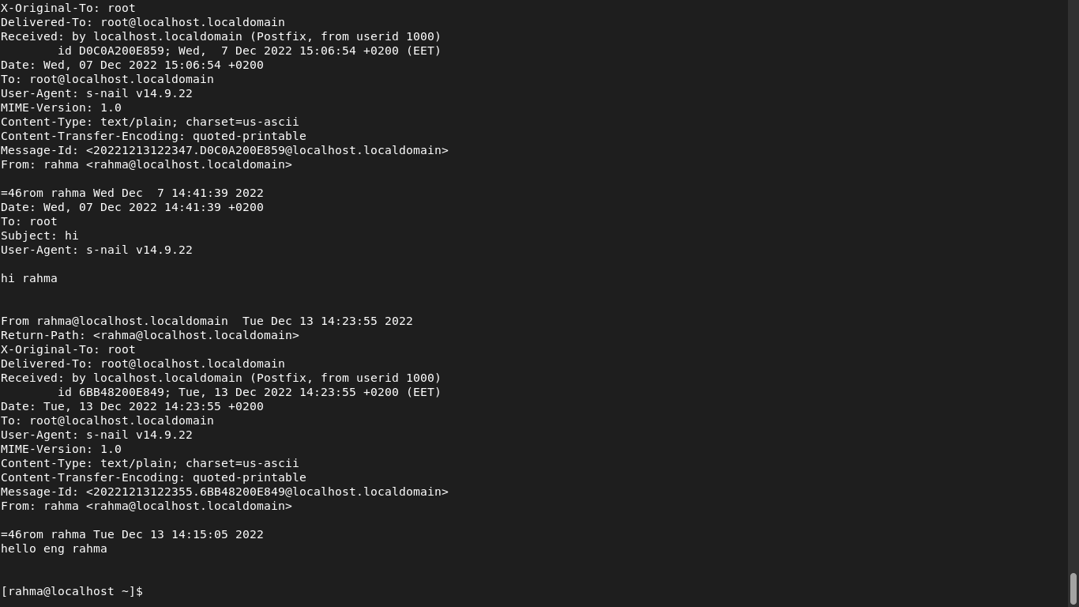
7.Verify that you have received this mail.

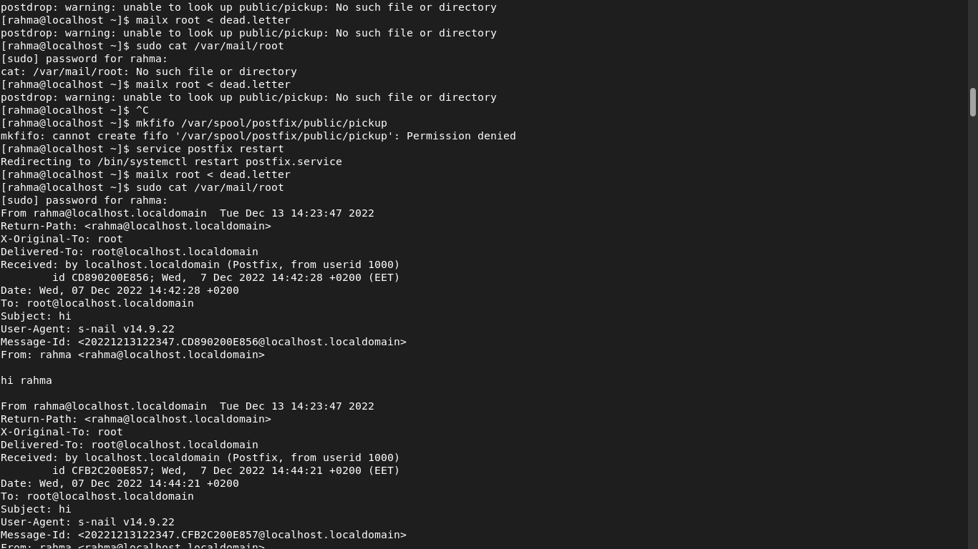
8. Use systemctl utility to start postfix service

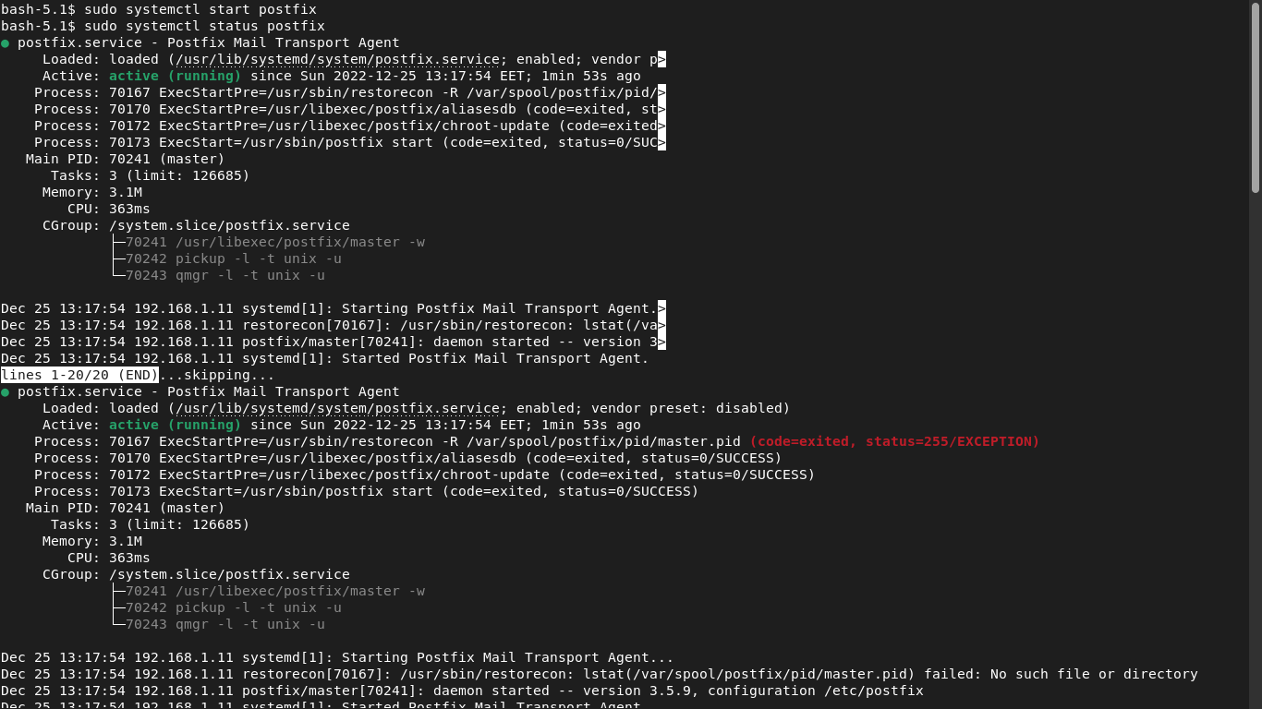

9. Verify that you have received this mail.

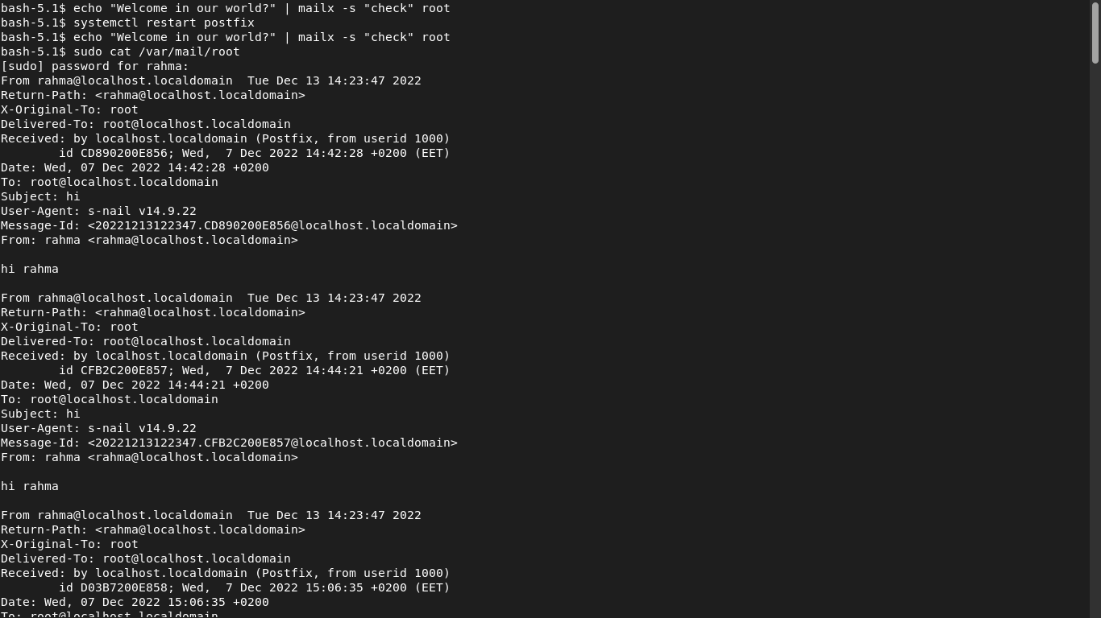

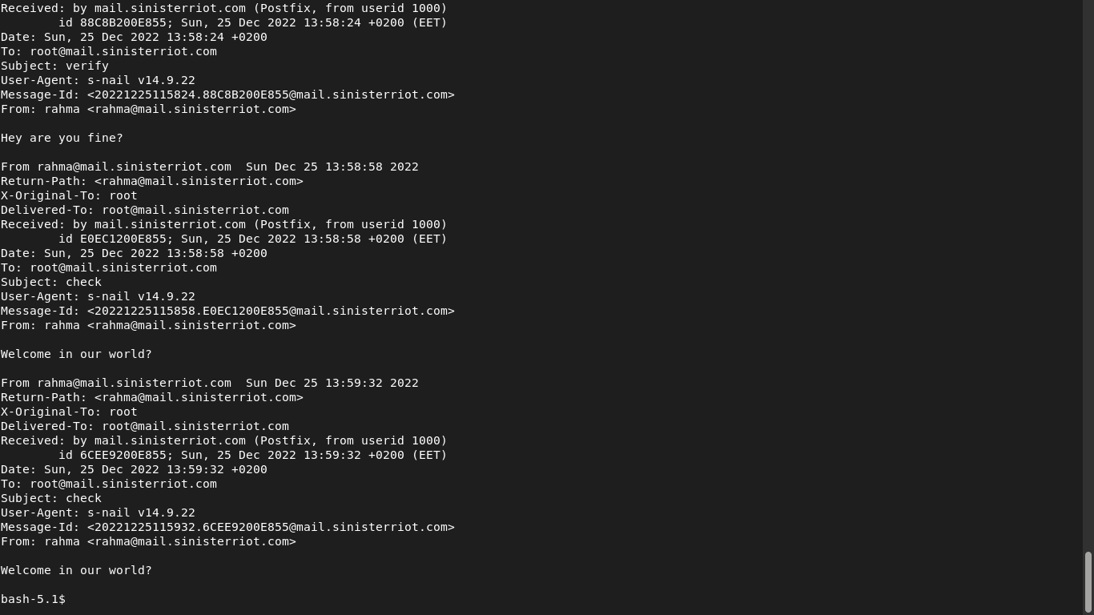
10. Edit in the GRUB2 configuration file and change the timeout variable equal to 20 seconds.
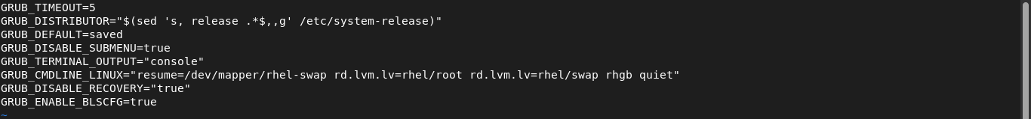
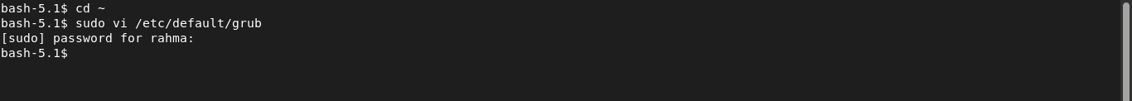

11. Edit in the GRUB2 configuration file and change your default operating system

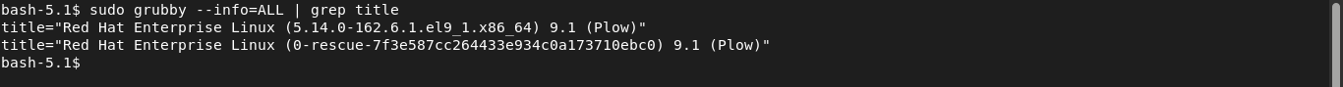

12. Install a new printer called "tty12" using web utility. Have the printer queue be "/dev/tty12" and specify a "Text Only Printer" for its model type.
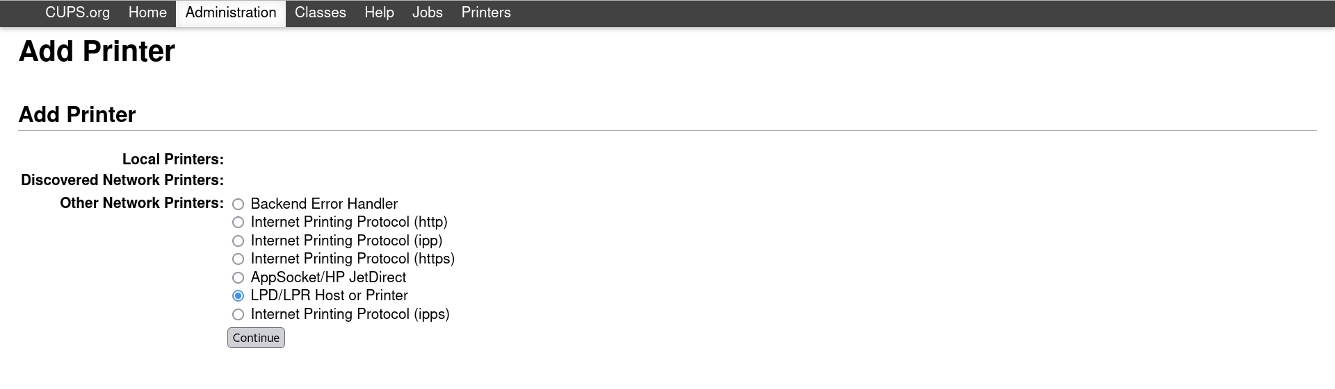

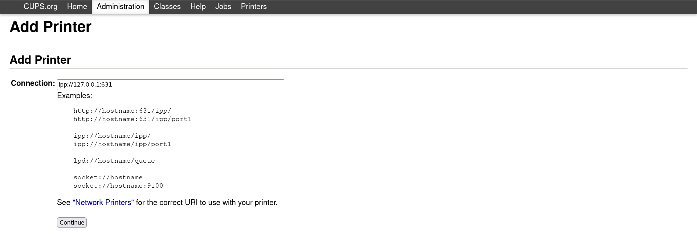

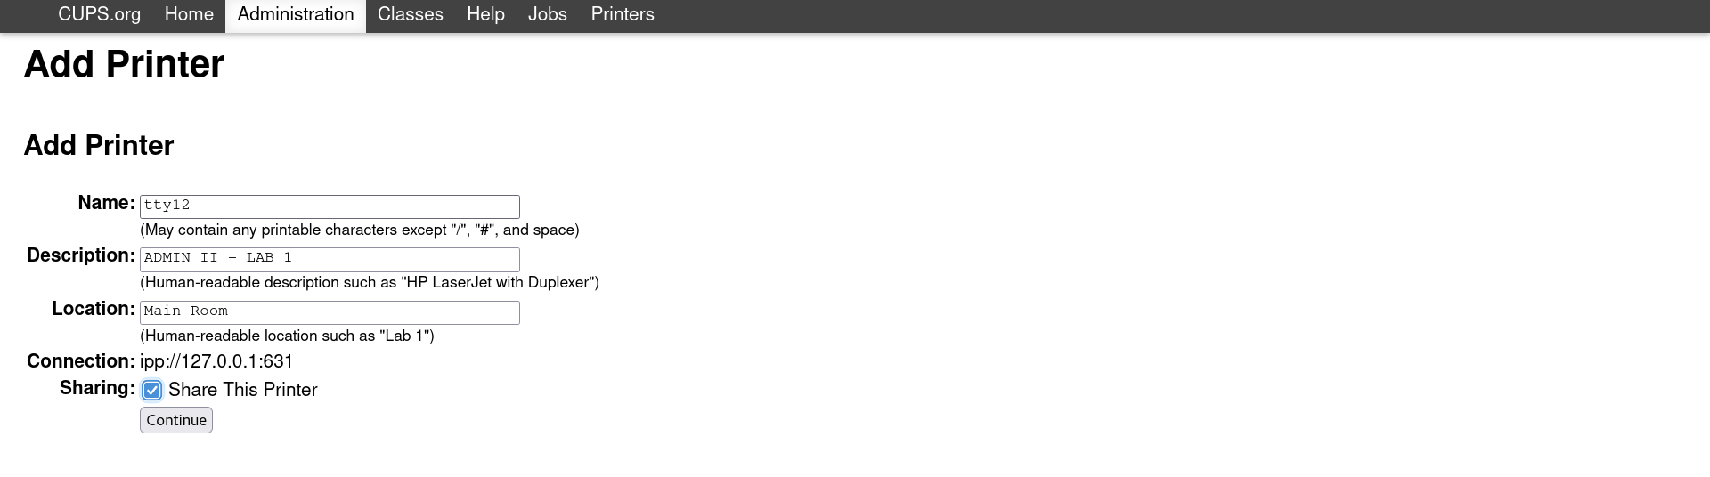

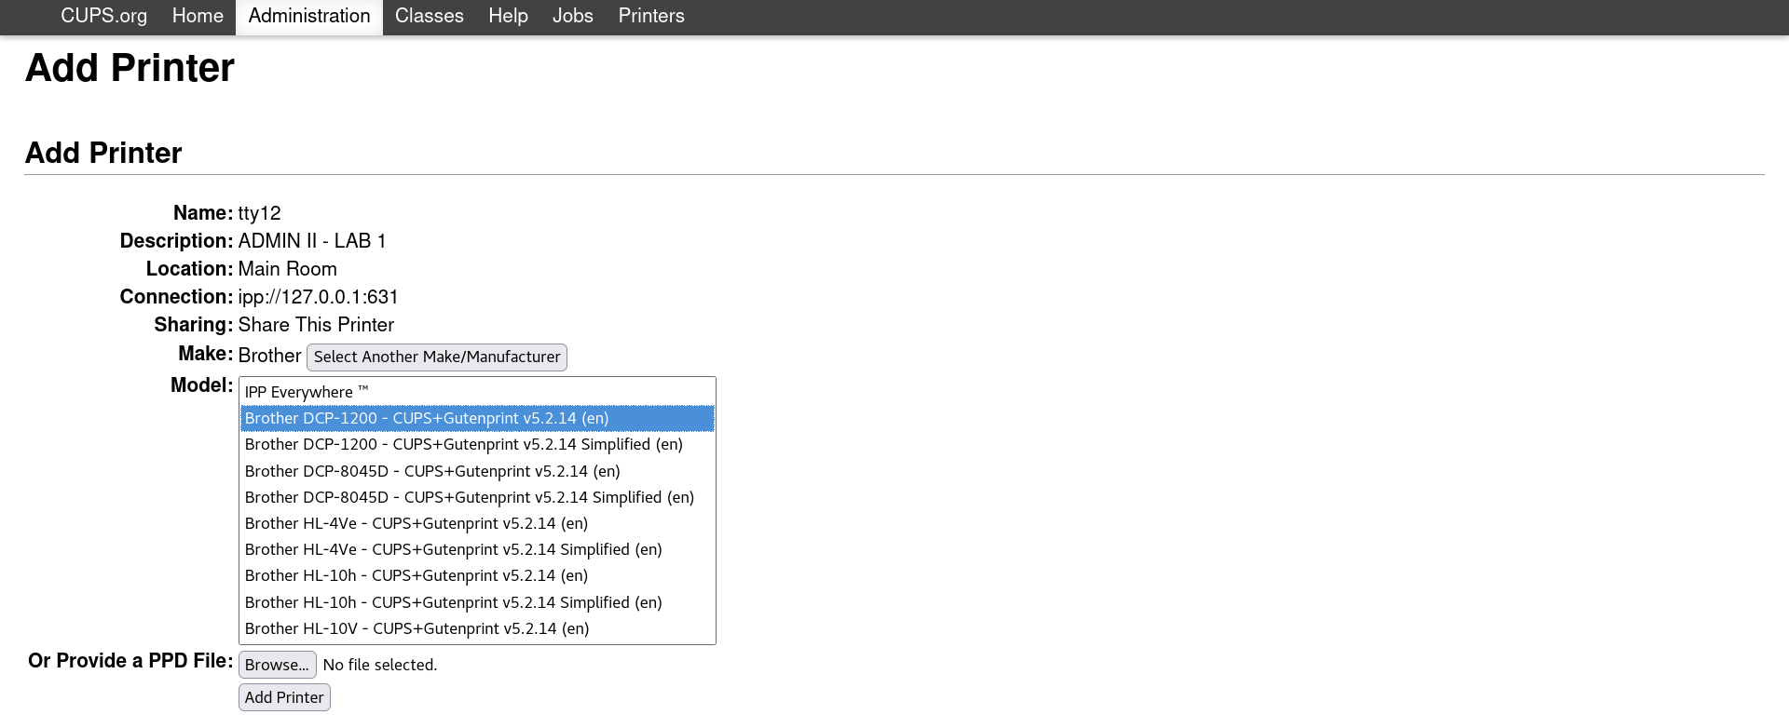

13. Print the file /etc/hosts to the printer and view the /dev/tty12 console to ensure that the print job went to the "printer".

lp -d tty12 “/dev/tty12”

14. Prevent jobs from leaving the tty12 printer queue to the printer. Do not prevent users from sending jobs to the tty12 printer queue.

Cups disable tty12
man cups
cups diasable tty12

15. Print three files (/etc/hosts, /etc/xinetd.conf, and /etc/hosts.allow) to the tty12 printer

lpc status

16. View the print queue.

Lp -d tty12 errors; lp -d tty12 file1 ; lp -d tty12 errorfile

lpq -a

17. Remove the second print job from the tty12 printer queue, and then allow the print jobs from the queue to be printed

lprm -p tty12 4
lpq -a

18. Prevent print jobs from going to the tty12 printer's print queue.

cupsreject tty12

19. Verify this by trying to print the /etc/hosts file.

lp -d tty12 /etc/hosts
lp: Destination "tty12" is not accepting jobs.

20. Delete the tty12 printer with the lpadmin command.

lpadmin -x tty12

21. You want to know some information about the status of the system every ten minutes today between the hours of 8:00 AM and 5:00 PM. to help investigate some performance issues you have been having. You suspect it might be memory related and want to keep an eye on those resources.

Crontab -e

22. Use mail as the root user to check for e-mail from the cron jobs you have scheduled.

23. How could you send the output from these cron jobs to another e-mail address (the manager user)?

24. Use mail as the manager user to check for e-mail from the cron jobs you have scheduled.

